**Class #4**

**Jenkins Slaves**

Now we are going to configure Jenkins slave

Here we are going to Install Instance in AWS

If we want to use any machine as a Jenkins slave in that machine Java(JDK) should be installed First

By following below process we will Install JDK

Before installing any software we should update machine by providing below cmd



It will update all the repositories in Machine

Now we are going to Install JDK



Once Installation is completed we have to add that Slave to Jenkins Master by following below process

Manage Jenkins>Manage Nodes>New Node

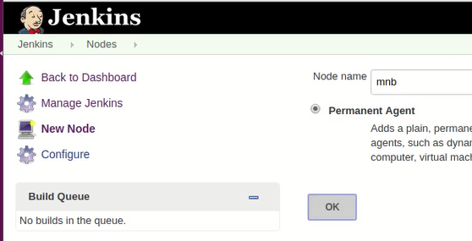

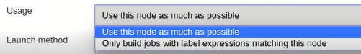

Usage means we will mention that the job details which we want to Run

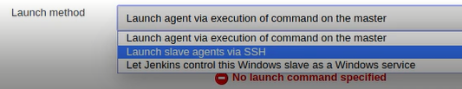

We will connect to slave by using SSH

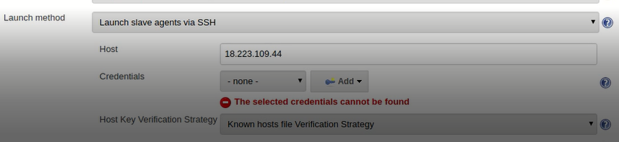

Above we have provided Host details slave IP and added the credentials by following below process

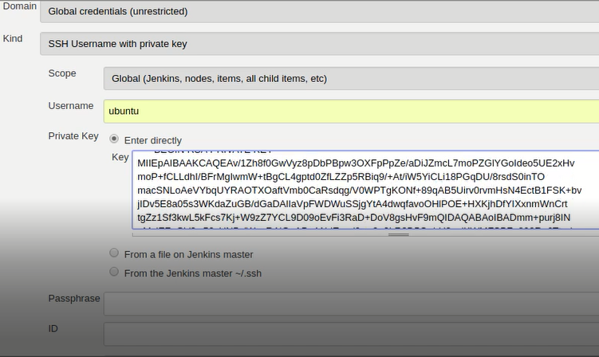

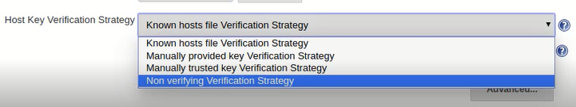

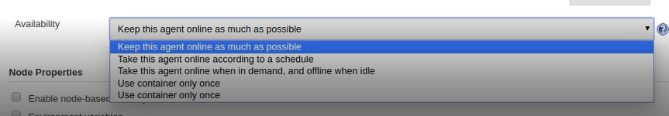

Then save it to complete slave creation

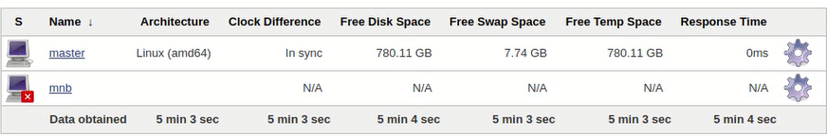

Slave is created, but it’s in offline mode we have to Launch it

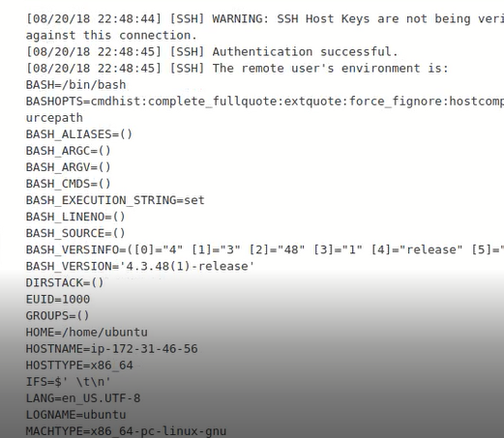

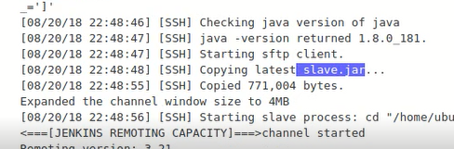

Whenever we are creating Slave slave.jar will generate and will placed in slave

By following above process we have created slave and we have Lunched

Now we are going to Assign Job to slave by following below process

Go to Job>General>Restrict where this project can be run> then provide the Name of slave

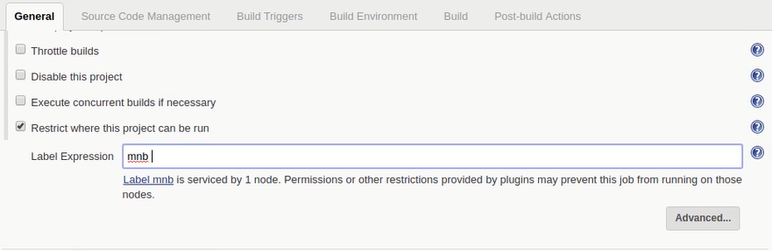

Now job is Running in Slave

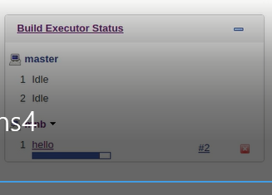

Above we have configured only for one Job

For example in our project we have 4 jobs and we want to add all four jobs to slave same process we have to follow

By configuring slave we will decrease work pressure on Master